**NAME:B.AKHIL VARMA**

**ROLL NO: 2420030141**

**SECTION: S-2**

**EXPERIMENT 3**

**3.Configure of basic switch setup using Cisco network switch using cisco packet tracer.**

**Step 1: Setting up the Network Topology**

**1.Open Cisco Packet Tracer.**

**2.Add devices:**

* Drag and drop a Cisco switch (e.g,2960) onto the workspace.
* Drag and drop two or more PCs onto the workspace.

**3.Connect devices:**

* Use the Connection option to select the Copper Straight Through Cable.
* Connect each PC to the switch using the FastEthernet ports(e.g., PC0 to FastEthernet0/1, PC1 to Ethernet0/2)

**Step 2: Configuring the switch**

1.Open the CLI (Command-Line interface) of the switch .

* Click on the switch and go to the CLI tab.

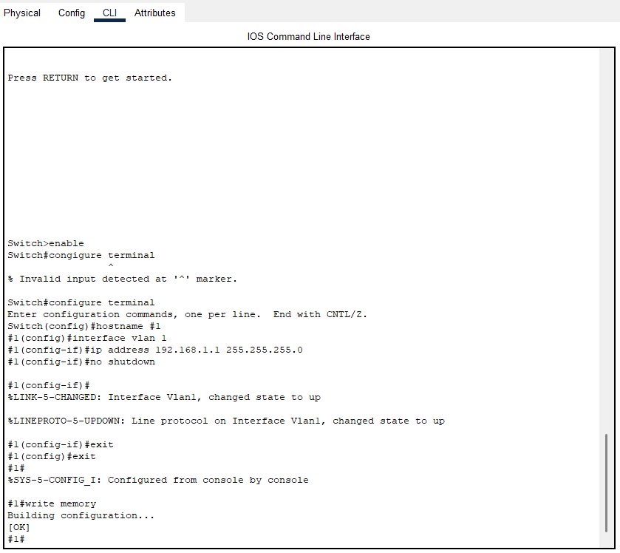

**Router Configuration Process:**

**1.Enter privileged EXEC mode:**

Switch>enable

Switch#

**2.Enter global configuration mode:**

Switch#configure terminated

**3.Configure the Switch host name (optional):**

Switch(config)#hostname #1

**4.Congigure VLAN 1(default VLAN)interface with an Ip address**

$1(config)#interface vlan 1

$1(config-if)#ip address 192.168.1.1 255.255.255.0

$1(config-if)#no Shutdown

$1(config-if)#exit

$1(Config)#

**5.Save the Configuration:**

$1(config)#exit

$1#writememory

**Step 3:Configure PCs**

**1.Assign IP address to PCs:**

* Click on each PC and go to the Desktop tab.
* Open the ip Configuration and assign an address within the same subnet as the switches VLAN 1 interface .For example

PC0:IP Address:192.168.1.2,Subnet Mask:255.255.255.0

PC1:Ip Address:192.168.1.3,Subnet Mask:255.255.255.0

**Step 4:Testing Connectivity**

1.Ping Between PCs:

* Open the Command Prompt on one of the Pcs(eg,.PC0)
* Use the ping Command to check connectivity to the other PC(e.g,. ping 192.168.1.3)

